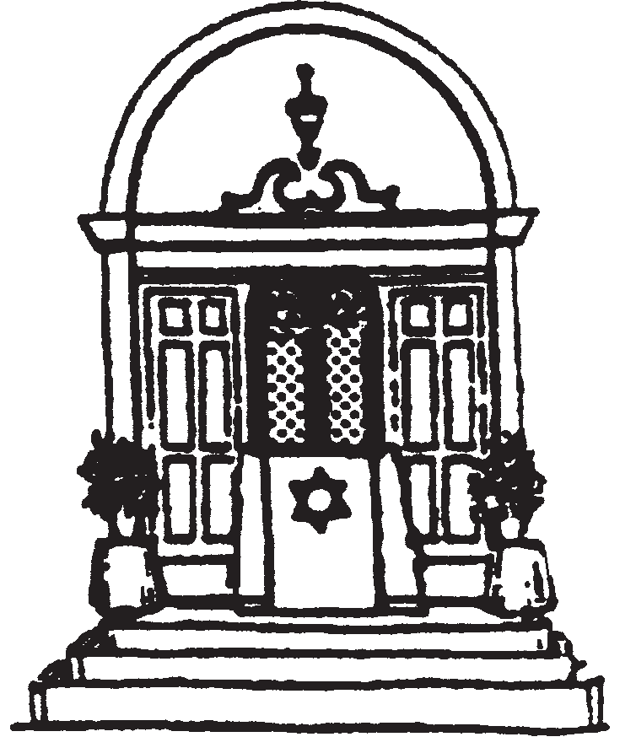
Pleasantville Community Synagogue
Hebrew School Calendar

September 2016 - May 2017
All classes will meet on Sundays and/or Thursdays.
Aleph/Bet (1st/2nd grade) will meet Sundays, 9 - 10:45 am
Gimel (3rd grade) will meet Sundays, 9 - 10:45 am*
Daled (4th grade) will meet Sundays, 10 am - 12 pm*
Hey (5th grade) will meet Thursdays, 4 - 6 pm and Sundays, 10 am - 12 pm
Vav (6th grade) will meet Thursdays, 4 - 6 pm and Sundays, 10 am - 12 pm
B’nei Mitzvah (7th grade) will meet Thursdays, 6:15 - 7:30 pm plus
one required parent-child program per month

*In addition to meeting in class on Sundays, 3rd and 4th grade students will have an online component to their learning during the week.

Please check the website at www.shalompcs.com for possible changes or updates.
Sunday, September 18………………………............................................................................First Day of Hebrew School
Sunday, October 9 (Columbus Day weekend)…………………………………………..……………….………No Classes

Friday evening, October 21……………………………………………………………………………….Aleph/Bet Shabbaton

Friday evening, November 18………………………………………………………………………………….Gimel Shabbaton
Thursday, November 24 – Sunday, November 27 (Thanksgiving)………..........………........................No Classes

Sunday, December 18…………….....................................................................................................Chanukah Celebration
Thursday, December 22 – Sunday, January 1 (Winter Recess)……...........………….......…....................No Classes

Sunday, January 15 (MLK Weekend)………………..…………...........…………..................................................No Classes

Friday evening, February 3........................................................................................................................Daled Shabbaton

Saturday evening, February 4……………...………….……………………………………………….Hey Havdallah Service
Sunday, February 19 – Sunday, February 26 (Presidents Week)……..............……………..................No Classes
Sunday, March 12……………………………………………………………………………………………….…Purim Celebration

Friday evening, March 17………...….…………...................……………………………….………......Aleph/Bet Shabbaton

Saturday morning, April 1………..………………..…………………………………………………………….....Hey Shabbaton

Sunday, April 2…………….…………………….………………...…..........................Model Passover Seder for Aleph/Bet
Thursday, April 6............................................................................Model Passover Seder for Gimel – B’nei Mitzvah

Sunday, April 9 – Sunday, April 16 (Passover) ………....................................................................…............No Classes

Sunday, April 23……………………………………………………...…Holocaust Remembrance Day Commemoration

Friday evening, April 28………………………...............................…...........................................................Gimel Shabbaton

Saturday morning, April 29............................................................................................................................Vav Shabbaton

Sunday, April 30………….…................................................................................Israeli Independence Day Celebration

Sunday, May 7……………………………………………………………………………………………………..Daled Heritage Day
Thursday, May 18.................................................Hebrew School Celebration / Last Day of B’nei Mitzvah Class
Friday evening, May 19.................................................................7th Grade (B’nei Mitzvah) Promotion Ceremony

Sunday, May 21…………………………………………………………………………….Last Day of Hebrew School Classes

