THE AFTERMATH OF GAZA:
What happened to relations between Jewish and Arab citizens of Israel?
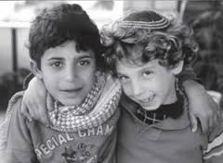

Join us for a fascinating evening
with Naomi Schacter
Associate Director of Shatil –The New Israel Fund’s (NIF) initiative for Social Change
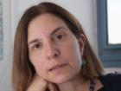
Thursday, December 4, 7:30 pm
Pleasantville Community Synagogue
219 Bedford Road, Pleasantville, NY
Naomi will discuss the challenges facing Israeli democracy in the aftermath of the war in Gaza, the current state of Israel’s minorities, and the work of the NIF and Shatil to promote democracy, justice and a shared society in Israel. For those of us deeply connected to Israel and its future, this is an important opportunity to hear from someone with first-hand experience and leadership in the field of human and civil rights in Israel.

For more information, please e-mail Israel Action Committee
co-chair Ofri Felder at ofelder@optonline.net or call the PCS office at 769-2672.
~~~

Pleasantville Community Synagogue
219 Bedford Road, Pleasantville, (914) 769-2672, info@shalomPCS.com
Celebrating 18 Years ~ Fair Share Dues means anyone can belong
Rabbi Mark Sameth ~ Galit Sperling, Principal
For the Top Ten Reasons to Join PCS visit www.ShalomPCS.com

