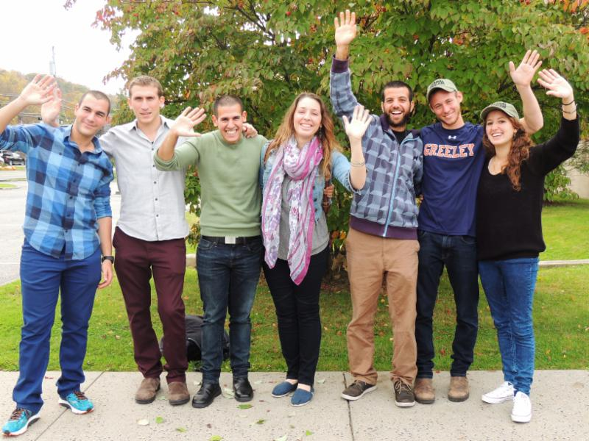

TZAHAL SHALOM IS ACCEPTING APPLICATIONS
FOR FAMILIES TO HOST or BUDDY AN IDF SOLDIER
OCTOBER 18 - OCTOBER 28, 2015

A 2015 delegation of 7 soldiers from the Israel Defense Forces
will be coming to Northern Westchester on
Sunday, October 18 until Wednesday, October 28.
This is the ninth delegation to be a part of our community.
Be a part of the magic of their stay.
Connect to Israel in a whole new way!
________________________________

Tzahal Shalom of Northern Westchester is offering a unique experience to have an active duty IDF soldier live with your family for 10 days this October.

The Tzahal Shalom program organizes each day for the soldier to be out in the community acting as good will ambassadors. Your job is to provide a bedroom and warm and welcoming family for the duration of the soldiers visit. We have hosted more than 56 soldiers over the past 9 years. It will, no doubt, be an amazing experience for your entire family.

If your family is interested in applying to be a host or buddy, or to volunteer to host parlor meetings, please email tzahalshalom@gmail.com.

