Pleasantville Community Synagogue
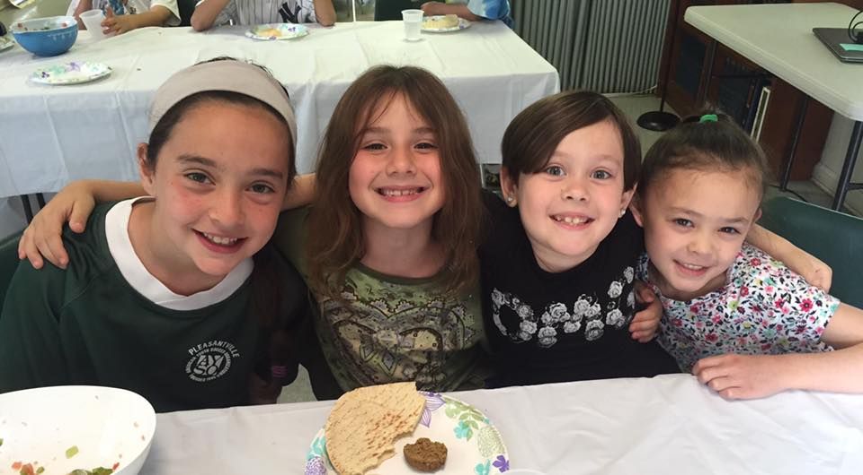
Hebrew School
Parents’ Handbook
2016-2017

219 Bedford Road, Pleasantville, NY 10570
Synagogue: (914) 769-2672
School: (914) 773-0043
info@shalompcs.com ~ principal@shalompcs.com
www.shalompcs.com

PLEASANTVILLE COMMUNITY SYNAGOGUE
RELIGIOUS SCHOOL 2016-2017
PARENTS’ HANDBOOK

Contents:

Mission Statement

Our Values

The Program

Enrichment Activities

School Attendance and Requirements

Arrival, Dismissal & Parking Procedures

Safety Precautions

MISSION STATEMENT

PCS Hebrew School is a trans-denominational and inclusive learning environment dedicated to providing a meaningful and developmentally appropriate Jewish education for our children. We are committed to fostering Jewish intellectual, emotional and spiritual growth for our students.
We seek to create an environment that cultivates life-long participation in Torah (study), Avodah (prayer), Gemilut Chasadim (acts of loving kindness), and Ahavat Israel (love of Israel). The education of our children depends upon supportive collaboration by teachers, parents and the entire PCS community.

OUR VALUES

At PCS it is our goal to instill in each student a deep respect for and a sound knowledge of Judaism. As part of their education, we seek to impart strong Jewish values in our classroom. These values have always been an integral part of our philosophy of Jewish education. Together they comprise a concept called menschligkeit or personhood. It is our hope that parents, teachers and the congregation will help our students understand how these values enrich their lives both in and outside the classroom.
We believe that each person is created B'tzelem Elokim (in the image of God); therefore, all members of the PCS Hebrew School Community must act with self-respect and with respect for all others.
We understand that the Jewish concept of Rachamim (mercy) means that we act
with compassion to all people.
It is understood that Emet (truth) is required to maintain a trusting, viable community.
Belief in Tikun Olam (making the world better) calls upon each of us to strive for
personal and group success.
We believe in Kol Yisrael Arevim Zeh l' Zeh (all of Israel is responsible for each other), and we are proud of our Jewish identity, both as American Jews, and as members of the worldwide Jewish community with special ties to Israel.
Our commitment to Talmud Torah (the study of Torah) demands we recognize that our education is both an obligation and a privilege.
Our belief in Kavod (treating people with dignity) and our efforts to avoid causing Bushah (embarrassment) means that we will strive to maintain the emotional and physical safety of all members of our community.
Our commitment to Darkhei Shalom (pathways to peace) means that we strive to communicate with each other in a peaceful manner.
Our understanding of the Jewish concept of Teshuvah (repentance) means that we recognize that we all make mistakes, have the capacity to turn away from these mistakes, and are capable of becoming kinder, more caring people.
.

THE PROGRAM

Using innovative techniques and creative resources, Pleasantville Community Synagogue seeks to accomplish its mission by offering a program that is responsive to the needs of the students. Our students will discover and experience our many traditions, our culture, and our values. They will study Bible, Israel, and holidays; as well as the Hebrew language and prayer to prepare them to be conversant at a synagogue service.
In the elementary grades (1st-4th), students are introduced to Jewish life and studies. They are given tools to set a foundation for learning in the Hebrew language, holidays, Torah, prayer, and Jewish values, culture and history.
 In their middle school years (5th-7th), students build on their proficiency in Torah, culture, and Jewish values, and are provided with Bar/Bat Mitzvah preparatory skills, as well as the building blocks of conversational Hebrew language.

ENRICHMENT ACTIVITIES

The curriculum for all grades includes various enrichment activities. The activities include programs specific to each class, to each grade as well as school wide programs. Some of the programs focus on the holidays, some focus on traditions while others are centered on cultural activities.

CLASS SHABBATONIM: One of the highlights of each year is the class shabbaton where the children help lead the service according to the level of the class. A special Oneg Shabbat sponsored by the class families follows the service. The Shabbatonim for Gan - Daled will be on a Friday night. Hey and Vav classes will have their Shabbatonim on a Saturday morning as part of an effort to familiarize them with the Shabbat morning service and to prepare them for their Bar/Bat Mitzvahs. Parents are strongly encouraged to attend services along with their children and are required to participate in the Family Education Shabbatot, which are led by the Rabbi.

TZEDAKAH: In the tradition of Judaism, we encourage students to give tzedakah (charity) on a regular basis. The amount is NOT important - it is the concept of giving from one’s self that is stressed.

MUSIC: We believe that music is an integral part of a well-rounded religious school experience. Music is therefore integrated into the curriculum, through holiday songs and selections from Jewish liturgy.

SYNAGOGUE SERVICE ATTENDANCE: In accordance with our Bar/Bat Mitzvah policy, students are obligated to attend Shabbat services at PCS a minimum of five times during their fifth grade year (either Friday night or Saturday morning), and 12 Shabbat services (5 Friday night and 7 Saturday morning) during their sixth and seventh grade years (four must be Family Education Shabbats). Parents are strongly encouraged to attend services along with their children, and required to participate in the Family Education Shabbats.

SCHOOL POLICIES & RULES

ADMISSION: Admission to Pleasantville Community Synagogue Religious School is open to the entire community through the second grade. (However, families are strongly encouraged to become members of the synagogue when the child is first enrolled.) From third grade on, the Religious School can only accommodate children of synagogue-member families. Parents are strongly encouraged to become active members in both synagogue life and school activities, since involvement is the key to a successful Jewish education. To be enrolled in our religious school children must be receiving an exclusively Jewish (religious) education.

STUDENT BEHAVIOR: Students are expected to behave properly and to show respect to each other, the teachers, and the synagogue. Inappropriate behavior is not only disruptive to the learning process but also undermines the Jewish values we try to teach. It requires prompt attention by the school and parental support of the disciplinary action. The teacher initially deals with disciplinary issues. If a problem persists, the parent will be notified, and the Educational Director will be involved. In order to maintain decorum and ensure their classmates’ ability to learn, disruptive students may be removed from the classroom.
In extreme cases, the Educational Director may recommend that the needs of the student be further evaluated. Recommendations will be made on how to meet those needs both in and outside the classroom setting. If it is determined that the student cannot benefit from classroom instruction, alternative arrangements for that student will be established. When that occurs, the cost of educating the child outside the classroom will be the responsibility of the family in lieu of Hebrew School tuition.
Students are expected to respect the synagogue building and property. Parents will be held liable for any damage incurred by their children.

DRESS CODE: All students are expected to be appropriately attired. Children are expected to wear kippot at all times in the sanctuary.

SCHOOL ATTENDANCE AND REQUIREMENTS

CLASS SCHEDULE: School begins with the Gan class (kindergarten), which meets for two hours twice a month. Aleph (first grade) and Bet (second grade) meet once a week, on Sundays, for two hours. Gimel (third grade) and Daled (fourth grade) meet once a week, on Sundays, for two hours, and have an additional component to their learning during the week, either online or in person. Hey (fifth grade) and Vav (sixth grade) meet twice a week on Sundays and Thursdays for a total of 4 hours of instruction. Zayin meets every Thursday evening for one hour and fifteen minutes, as well as monthly on a Sunday morning, for a required parent-child learning event.

ATTENDANCE AND REQUIREMENTS: The curriculum is most effective when a child attends and participates on a regular basis. Regular attendance enhances student learning, attitude and class morale. Skills and content are mastered cumulatively. Casual and frequent absences work against the child’s ability to be successful in Hebrew School.
Prompt regular attendance and completion of assigned work is essential to the sustained learning this program is designed to achieve. To progress to a higher grade the students are required to maintain at least 75% attendance and complete 100% of the work. Excessive absences will result in an incomplete which must be made up. If a student misses more than 25% of Hebrew School classes, parents will be contacted to discuss the reason for the absence. Arrangements should be made to have assignments sent home to keep the student current.

TIME OF ARRIVAL: Students are expected to arrive and be ready to begin work at the start of class time.

LATE ARRIVAL: Students who are late for class should bring a note signed by a parent, or give notice by emailing the Educational Director.

LEAVING EARLY: Leaving before class is concluded is extremely disruptive and should be kept to an absolute minimum. In order for such a request to be honored the student must bring a note signed by a parent stating the reason and the requested time of dismissal. To ensure the safety of our children, we will not permit any child under 12 years old to leave the building unsupervised.

EDUCATIONAL MATERIALS AND HOMEWORK: PCS will provide necessary texts and materials for classroom work. Specific homework assignments are left to the discretion of our teachers with the understanding that it is the school’s policy not to overburden the students. At times, homework assignments are used to reinforce class material and give the students an opportunity to respond creatively. Students are expected to complete all homework assignments accurately and promptly. It is especially important for parents to encourage their children to spend time each day reviewing their Hebrew reading skills. This time spent daily will help the students become proficient in Hebrew reading.
PROGRESS REPORTS: Progress reports will be emailed home twice a year. Individual parent-teacher conferences are encouraged and may be arranged with the teacher at a mutually convenient time.

FOOD: Snacks will be provided to all students at appropriate times. To ensure the observance of Kashrut, students are not permitted to bring food into the classrooms, except for authorized classroom celebrations. Bringing a bottle of water to class is permitted. Gum chewing is not allowed inside the classrooms. Parents should notify the school office of any allergies, and any medical requirements or issues.

ARRIVAL, DISMISSAL & PARKING PROCEDURES

The safety of our students is of the utmost importance to us. The parking lot of the Synagogue cannot be used to drop off or pick up students. NO STOPPING on Bedford Road is allowed under any circumstances. Parking is available either on Clark Street or Ashland Avenue. Please observe the NO PARKING signs (parking is only permitted on the south side of Clark Street). Parents are expected to walk up to the main or side door of the synagogue to pick-up/drop off their children. Please inform us if there is any change in your child’s pick-up arrangement (new car pool, new nanny, etc.).
To ease congestion, the following suggestions should be considered:
 Carpool your children to Hebrew School. This eases congestion, increases parking availability and lessens your day-to-day driving responsibilities.
 Designate one adult to bring a group of children to the appropriate cars. This makes pick-up less crowded and also ensures that everyone will be safe getting to his or her car.
 Children in 1st through 6th grade must be picked up by an adult or older sibling (12 years or older);
 Children under the age of 12 will not be permitted to leave the building unescorted.
 Children 12 or older who live within walking distance of the Synagogue, or are allowed to walk by themselves to the corner of Clark Street, must have a permission slip signed by a parent and submitted to the Hebrew School Office so that they may be released to walk home in groups or on their own. No student will be allowed to leave the building unsupervised unless they have a permission slip.
 The synagogue must be notified if a child will be walking to PCS on Thursday afternoons. Children who will be walking to PCS must sign in upon arrival before going to class. If the student will be absent, the parent must notify the Hebrew School.
SCHOOL CLOSING PROCEDURES: If Hebrew school is cancelled due to inclement weather or dangerous road conditions, an email will be sent out to all parents. We will follow the Pleasantville Public School closing schedule on Thursdays.

SAFETY PRECAUTIONS

FIRE DRILLS: Fire drills will be held periodically under the direction of the Pleasantville Fire Department. We want to make sure that everyone is able to leave the building safely and quickly in the event of an emergency.

FIRST AID: If a child receives a minor cut while at school it will be cleansed and bandaged. In case of more serious injury the parent will be notified immediately. If there is an emergency and the parent cannot be reached, the child will be taken to Northern Westchester Hospital. Parents should notify the school office of any allergies, particularly to medications or food, and any other medical requirements.

