We are less when we don’t include everyone.
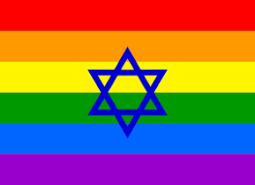
All are invited to
Celebrate Pride Shabbat
at the
Pleasantville Community Synagogue
Friday evening, June 29, 7 pm
Please contact Leslie Mack at lesrn3259@aol.com if you are interested in coming and/or if you have ideas for the service.
A dessert oneg will follow the service.
~~~
Pleasantville Community Synagogue is a welcoming Jewish community with people of diverse traditions and backgrounds who want to share a joyous spiritual and cultural home.
Pleasantville Community Synagogue
www.ShalomPCS.com ~ (914) 769-2672 ~ info@shalomPCS.com
219 Bedford Road, Pleasantville, NY

