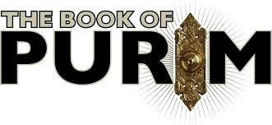
Continuing ADULT EDUCATION on Wednesdays at PCS with RABBI JULIE
Feb. 3 and 24, 7:30 pm.
All are welcome and no previous knowledge is necessary.
Part One: February 3, 7:30 pm
The Whole Megillah
The Megillah in the Context of the Bible
What is the "back story" of the Book of Esther? Its historical context? How does the Book of Esther both fulfill and subvert other biblical traditions? Is it history, melodrama, satire, the first Jewish novel maybe?
This is your opportunity to read the Whole Megillah and understand it like you never learned in Hebrew School!

Part Two: February 24, 7:30 pm
Does this Book Belong in the Bible?!
The Megillah in the Context of Rabbinic Thought and Theology
The Scroll of Esther is full of sexual innuendo, violence, and court intrigue -- and it doesn't mention the name of G-d even once. Yet some consider this story of assimilated diaspora Jews a uniquely holy expression of divinity. We will look at Talmud and Midrash, and ponder how this book got into the Bible at all.
Following our Talmudic sages, we will take a vote at the end of class if we think it belongs there.

Lots of participation and discussion!
Each class stands on its own, but together you get the whole picture -- the Whole Megillah!

~~~

Pleasantville Community Synagogue is a welcoming Jewish community with people of diverse traditions and backgrounds who want to share a joyous spiritual and cultural home.
Visit www.ShalomPCS.com~ (914) 769-2672 ~ info@shalomPCS.com
219 Bedford Road, Pleasantville, NY 10570

For parking info, please visit www.shalompcs.com/directionsandparking.
During services and other events, parking spots at synagogue are priority for disabled and elderly visitors.

