SpeakChorus Torah returns to PCS!

Dear PCS friends,
It was so wonderful to see so many of you at Shavuot and Rabbi Julie's installation, and I'm looking forward to another Awe-some time with Rabbi Julie and all of you at High Holidays! The choir has been rehearsing all summer and adding some new material. I'm especially excited that all of YOU have an opportunity to be involved in preparing and presenting a new SpeakChorus Haftarah.

Do you remember the amazing SpeakChorus Torah presentation at Yom Kippur two years ago? Well, I'm thrilled that we are once again creating a unique group midrash/creative group interpretation, this time focused on the words of Isaiah in chapter 58, the second half of the haftarah for Yom Kippur.

We need YOU to help make it happen by becoming a Writer or Speaker. You don't have to be an experienced writer or performer, just be willing and interested. Teens, you can join us, too.

Writers: OPEN TO ALL. A number of you already began this process at our Erev Shavuot study session, and I'm pleased to invite others to join in. Click here to find the readings, writing exercises and instructions for sending in your written words to be included in our SpeakChorus Haftarah.

Speakers: We need at least 4 speakers. You must be available Yom Kippur morning, and willing to meet 3 times to work on and with the script. To express interest in being a Speaker in the SpeakChorus at Yom Kippur, email cantorabbe@yahoo.com

Looking forward to singing, praying and learning with all of you!

Cantor Abbe
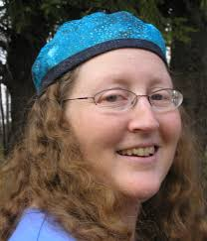

cantorabbe@yahoo.com
www.abbelyons.com

