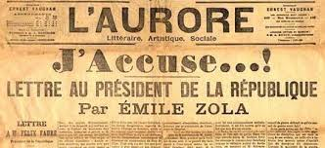
The Dreyfus Affair:
Art, Truth and Justice

Pleasantville Community Synagogue is proud to host a fascinating presentation
by the Jewish Museum of New York.
Through art, we will gain an understanding of a series of events from
1894-1906 when Captain Alfred Dreyfus, a French army officer
and a Jew, was falsely accused and convicted of treason.
Tuesday, April 28, 7:30 pm
This public event is free but donations are always welcome.
~~~
Pleasantville Community Synagogue
www.ShalomPCS.com
(914) 769-2672 ~ info@shalomPCS.com ~
219 Bedford Road, Pleasantville, NY

Sponsored by the PCS Adult Education Committee.

