COME to PCS to CELEBRATE
TU B’SHVAT!
With Maayan Leshem
Tuesday, February 3, 7:30 pm
at Pleasantville Community Synagogue
Join us for a free and fascinating workshop that will explore the seven species
of the Land of Israel through story, music, study, and of course – the traditional Tu B’Shvat fare of dried fruits, nuts and wine.
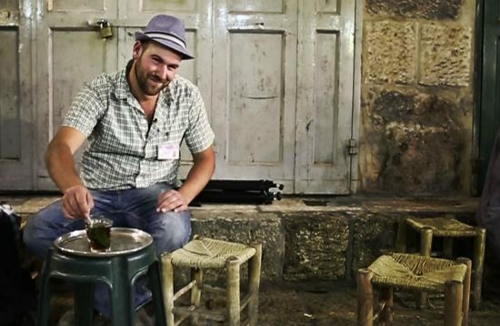
Maayan Leshem is a Jewish educator and licensed tour guide who lives in Jerusalem with his wife
and two children. His tours, classes and workshops focus on Jewish identity, Zionism, ecology and
the deep connection between the People of Israel and the Land of Israel.
Sponsored by PCS Israel Action Committee. Refreshments will be served.
E-mail ofelder@optonline.net or call PCS at 914-769-2672
~~~
Pleasantville Community Synagogue
Celebrating 18 Years ~ Fair Share Dues means anyone can belong
For the Top Ten Reasons to Join PCS visit: www.ShalomPCS.com
(914) 769-2672, info@shalomPCS.com ~ 219 Bedford Road, Pleasantville, NY

