Looking for the perfect Israeli wine
for the holidays?
Looking for a really fun evening
with great company?
If so, sign up now for the
PCS-sponsored Wine Tasting
Tuesday, Sept. 9, 7 pm
at Best Wine Purveyors in Pleasantville.
Seating is limited so RSVPs by September 5 are a must… *
Call 769-2672 or e-mail PCS now to make sure you have a place at the table!
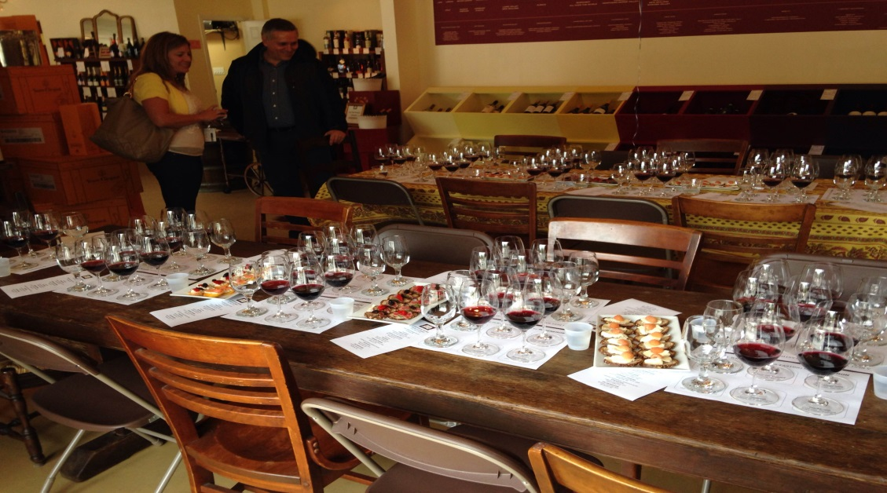
Joyful Judaism!

Pleasantville Community Synagogue
www.ShalomPCS.com
(914) 769-2672 ~ info@shalomPCS.com ~ 219 Bedford Road, Pleasantville, NY
* $20 tasting fee ~ A portion of the proceedings and all sales
will be donated to Israel’s Magen David Adom.

